- 有關荷爾蒙治療前列腺癌之副作用，下列何者為非？
  - 體重增加、認知功能下降、貧血等
  - 骨折風險增加至約20%
  - 停止荷爾蒙治療後，Testosterone恢復至治療前狀態的中位時間需十個月
  - 心血管疾病的發病率會降低20%
    - Ｄ (Prostate ca)
      - 易
        - Perez and Brady’s Principles and Practice of Radiation Oncology, Edward C. Halperin, David E. Wazer, Carlos A. Perez, Luther W. Brady; Chapter 66, p1326; 2013.6th.
          - P1326, …the potentially serious complications of AST. These include fatigue, weight gain, osteoporosis, depression, decreased cognitive function, erectile dysfunction, loss of libido, gynecomastia, anemia, decreased high-density lipoprotein, insulin resistance, and hot flashes…. the addition of AST significantly increased the risk of any fracture from 12.6% to 19.4%; fractures requiring hospitalization similarly increased from 2.37% to 5.19%.... In a study by Pickles et al.,¹¹⁵the overall median time for testosterone recovery to noncastrate levels after adjuvant AST and radiotherapy was 10 months…. A similar study by Saigal et al.¹¹¹ of 22,816 patients accounted for ethnicity and confirmed that the use of AST was associated with a 20% increase in cardiovascular morbidity.
- 前列腺癌接受放射治療，有關PSA之敘述何者為非？
  - 若PSA短暫上升，病人將來PSA控制率較差
  - PSA bounce: 治療後PSA比nadir至少增加0.2ng/mL後再降回nadir甚至更低之值
  - biochemical failure: 追蹤PSA達nadir+2或以上
  - PSA doubling time越短，遠端轉移的機率可能越高
    - A (Prostate ca)
      - 易
        - Perez and Brady’s Principles and Practice of Radiation Oncology, Edward C. Halperin, David E. Wazer, Carlos A. Perez, Luther W. Brady; Chapter 65, p1309-1310; 2013.6th.
          - P1309, A transient increase of PSA during radiation therapy, even as soon as the first fraction, has been reported in some patients.^{364,365} Because there is no prognostic significance to the PSA response during a course of radiation therapy, obtaining PSA levels during treatment is not necessary or recommended.
- 前列腺癌目前已確定之風險因子，下列何者為非？
  - 雄性素
  - 年齡
  - 膳食脂肪
  - 家族史
    - A (Prostate ca)
      - 中等
        - Perez and Brady’s Principles and Practice of Radiation Oncology, Edward C. Halperin, David E. Wazer, Carlos A. Perez, Luther W. Brady; Chapter 65, p1282; 2013.6th.
          - P1282, Table 65.1
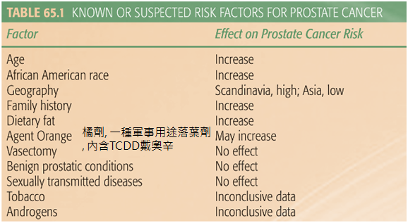
- 關於PSA，下列何者為誤？
  - PSA是前列腺分泌的酵素，有使精液凝塊液化的功能
  - PSA 上升速率若每年大於0.75ng/mL，罹患前列腺癌的機率增加
  - 罹患前列腺癌者，其free PSA與total PSA的比值較良性攝護腺肥大者低
  - PSA密度越高，越偏向良性攝護腺肥大
    - D (Prostate ca)
      - 易
        - Perez and Brady’s Principles and Practice of Radiation Oncology, Edward C. Halperin, David E. Wazer, Carlos A. Perez, Luther W. Brady; Chapter 65, p1281、p1289; 2013.6th.
          - P1289, A rate of rise of >0.75 ng/mL per year has been associated with a higher frequency of cancer. A higher PSA density is associated with malignancy. Men with prostate cancer and either a normal or an enlarged gland had a significantly lower percentage of free PSA than men with benign prostatic hyperplasia only
P1281, PSA is a serine protease that is involved in the liquefaction of the seminal coagulum.
- 關於膀胱癌，何者為非？
  - 最好發的位置在膀胱前壁
  - 常是多發性病灶
  - 最常見的症狀是血尿
  - 若有髂總淋巴結轉移，依據第七版AJCC分期，為N3
    - A (bladder ca)
      - 中等
        - Handbook of Evidence-based Radiation Oncology, Eric K. Hansen, Mack Roach III; Chapter 25, p419, p421; 2010,7th.
          - P419, Tumors tend to be multifocal in nature…Most common sites = trigone (inferiorly below ureterovesical junctions), lateral and posterior walls, and bladder neck…Common presenting symptoms: hematuria (gross or microscopic; 75% of cases), irritative voiding (25–30%), pelvic pain, obstructive uropathy, hydronephrosis
P421,
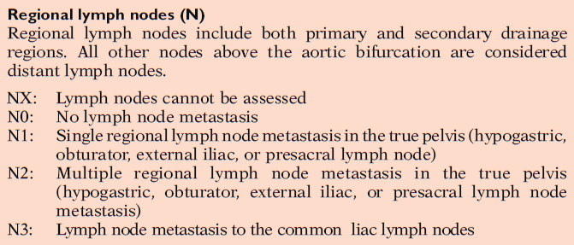
- 關於低風險性膀胱癌，何者為非？
  - 為單一顆腫瘤
  - 包含原位癌
  - 直徑小於3公分
  - 組織型態為G1
    - Ｂ (bladder ca)
      - 中等
        - Perez and Brady’s Principles and Practice of Radiation Oncology, Edward C. Halperin, David E. Wazer, Carlos A. Perez, Luther W. Brady; Chapter 64, p1264; 2013.6th.
          - P1264, Low-risk tumors are single tumors that are <3 cm in diameter are graded as G1 disease and staged as Ta with no evidence of CIS. These tumors have a 15% probability of recurrence and a 0.2% risk of progression at 1 year.³⁰ These patients should undergo a flexible cystoscopy 3 months after the initial resection, and if this is negative, a flexible cystoscopy should be undertaken 9 months later and then annually thereafter.
- 關於膀胱癌，何者為非？
  - 抽菸為其危險因子
  - 血吸蟲為其危險因子
  - 慢性發炎相關的膀胱癌病理型態主要是腺癌與鱗狀上皮癌
  - 膀胱長出的小細胞癌對化學治療的反應不佳
    - D (Bladder ca)
      - 易
        - Perez and Brady’s Principles and Practice of Radiation Oncology, Edward C. Halperin, David E. Wazer, Carlos A. Perez, Luther W. Brady; Chapter 64, p1261、p1263; 2013.6th.
          - P1261, Squamous cell carcinoma and adenocarcinoma of the bladder often occur in the presence of chronic inflammation.
P1263, In excess of 90% of bladder cancers are transitional cell carcinomas. Of the remainder, around 5% are squamous, although it should be noted that squamous differentiation is often present in poorly differentiated TCCs, so the extent to which these are genuinely distinct is open to question. As already noted, infestation with S. haematobium can lead to squamous cell carcinoma, but this is rapidly decreasing due to eradication programs. Small cell carcinoma is rare but important as it is generally very chemosensitive and treatment tends to follow schedules adapted from treating small cell lung cancer
- 泌尿道癌，下列何者為誤？
  - 上泌尿道癌常見多發性病灶
  - 輸尿管癌易發生於中段三分之一處
  - 腎細胞癌最常見的症狀是血尿
  - 腎髓質癌與鐮刀狀血球疾病相關
    - B (Cancer of the kidney, renal pelvis and ureter)
      - 中等
        - Perez and Brady’s Principles and Practice of Radiation Oncology, Edward C. Halperin, David E. Wazer, Carlos A. Perez, Luther W. Brady; Chapter 63, p1246, p1248; 2013.6th.
          - P1246, Ureteral tumors tend to occur in the distal third of the ureter.
- 腎細胞癌的風險因子何者為非？
  - 長期抽菸
  - Ｃ型肝炎
  - 體染色體顯性多囊性腎病
  - 高血壓
    - C (Cancer of the kidney, renal pelvis and ureter)
      - 易
        - Perez and Brady’s Principles and Practice of Radiation Oncology, Edward C. Halperin, David E. Wazer, Carlos A. Perez, Luther W. Brady; Chapter 63, p1245-1246; 2013.6th.
          - P1245, Long-term cigarette smoking is associated with an increased risk of developing RCC. Obesity, diabetes, hepatitis C, and hypertension are also associated with a higher relative risk for development of these tumors. P1246, Autosomal dominant polycystic kidney disease dose not appear to increase the incidence of RCC.
- 何種癌症最常轉移至陰莖？
  - 肛門
  - 肺
  - 膀胱
  - 大腸
    - C (Cancer of the penis and male urethra)
      - 中等
        - Perez and Brady’s Principles and Practice of Radiation Oncology, Edward C. Halperin, David E. Wazer, Carlos A. Perez, Luther W. Brady; Chapter 68, p1348; 2013.6th.
          - P1348, Cancer metastatic to the penis are rare and usually represent late, advanced carcinomatosis. The most common neoplasms metastasizing to the penis are from the genitourinary organs, followed by the gastrointestinal and respiratory systems (Table 68.3)
- 陰莖癌與下列何者較無關聯？
  - 包莖(Phimosis)
  - 人類乳突病毒type 6/11
  - 妻子罹患子宮頸癌
  - 新生兒包皮環切術
    - B (Cancer of the penis and male urethra)
      - 易
        - Perez and Brady’s Principles and Practice of Radiation Oncology, Edward C. Halperin, David E. Wazer, Carlos A. Perez, Luther W. Brady; Chapter 68, p1345; 2013.6th.
          - P1345, There is increasing evidence that newborn circumcision has a preventive effect in the development of carcinoma of the penis. Phimosis is common in men suffering from penile carcinoma. Human papilloma virus (HPV) is associated with penile carcinoma. In a systematic review of the literature, Miralles-Guri et al.12 concluded that approximately half of all carcinomas are HPV related, with the most common serotypes being HPV-16 and HPV-18. Martinez14 in Puerto Rico and Graham et al.15 in New York also noted a significantly higher incidence of carcinoma of the cervix in the wives of males with penile.
- 依據第七版AJCC分期：陰莖癌侵犯至尿道，有兩側鼠蹊部淋巴結轉移及節外侵犯，此外無其他遠端轉移，分期為？
  - T3N3M0
  - T3N2M0
  - T2N2M0
  - T2N3M0
    - A (Cancer of the penis)
      - 易
        - Perez and Brady’s Principles and Practice of Radiation Oncology, Edward C. Halperin, David E. Wazer, Carlos A. Perez, Luther W. Brady; Chapter 68, p1347; 2013.6th.
          - P1347,
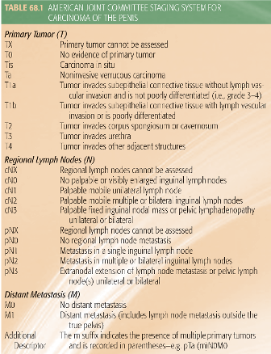
- 關於尿道癌，下列何者為誤？
  - 常見的臨床症狀是尿路阻塞
  - 原發部位大多位於後區尿道，預後較差
  - 最常見的病理組織型態為鱗狀上皮細胞癌
  - 臨床上常見血行性散布，約占四成至六成
    - D (Cancer of the penis and male urethra)
      - 中等
        - Perez and Brady’s Principles and Practice of Radiation Oncology, Edward C. Halperin, David E. Wazer, Carlos A. Perez, Luther W. Brady; Chapter 68, p1346, p1348; 2013.6th.
          - P1346, Hematogenous spread is uncommon except in advanced regional disease. Kaplan et al. reported distant metastases in about 15% of patients; most had corpora cavernosa invasion at diagnosis. Patients with urethral carcinoma most commonly present with obstructive symptoms (43%). The majority of urethral carcinomas occur in the bulbomembranous (posterior) region (61%), and tumors in this location have a worse prognosis compared with those arising in the anterior urethra. P1348, The histological subtypes in the Memorial Sloan-Kettering Cancer Center series of urethral cancers included squamous cell carcinoma (52%), transitional cell carcinoma (33%), epidermoid carcinoma (11%), adenocarcinoma (2%), and anaplastic carcinoma (2%)
- 有關睪丸癌，下列何者為誤？
  - 九成以上為生殖細胞瘤
  - 精母細胞性精原細胞瘤比典型精原細胞瘤更容易發生遠端轉移
  - 混和性生殖細胞瘤最常見的成分是胚胎癌
  - 畸胎瘤通常AFP與β-HCG不會升高
    - B (Testicular ca)
      - 中等
        - Perez and Brady’s Principles and Practice of Radiation Oncology, Edward C. Halperin, David E. Wazer, Carlos A. Perez, Luther W. Brady; Chapter 67, p1334-1335; 2013.6th.
          - P1334, More than 95% of testicular neoplasms are germ cell tumors and are divided into seminomas and nonseminomas.
P1335, Spermatocytic seminoma is confined to the testes and is cured by orchidectomy. Metastasis is rare. Embryonal carcinoma is the most common component in mixed tumors…. Teratoma is not associated with elevated AFP or HCG
- 放射治療Seminoma，下列何者為誤？
  - 典型的Dog-leg的PTV，上緣界於T9及T10椎體之間
  - 改良型Dog-leg的PTV，減少external iliac lymph nodes的照射範圍
  - 照射範圍需包含Interaortocaval、Preaortic、Para-aortic、Inguinal淋巴節及部分陰囊
  - 左側的Seminoma建議包含左側renal hilar，以及hemipelvis淋巴節
    - C (Testicular ca)
      - 易
        - Perez and Brady’s Principles and Practice of Radiation Oncology, Edward C. Halperin, David E. Wazer, Carlos A. Perez, Luther W. Brady; Chapter 67, p1341; 2013.6th.
          - P1341, For stage I disease, the clinical target volume (CTV) encompasses the interaortocaval, preaortic, and para-aortic nodes. The left renal hilar nodes are included for left-sided tumors. The ipsilateral external iliac and common iliac nodes may also be included, particularly if there is concern about aberrant drainage. Inclusion of the inguinal scar, inguinal lymph nodes, or hemiscrotum is not routinely warranted. The PTV includes the CTV plus a margin to account for positional and setup uncertainties. To cover the known location of the retroperitoneal and iliac lymph nodes with an appropriate margin, standard anatomic field borders have been used. This is commonly referred to as the dog-leg or hockey stick field. Classically, the superior border is placed between the T9 and T10 vertebral bodies, with the inferior border at the top of the obturator foramen. A modified approach is now commonly used wherein the superior border is placed between T11 and T10 and the inferior border is placed at the superior aspect of the acetabulum

